Project Development Phase
Model Performance Test

Date | 10 February 2025
Team ID | PNT2025TMID08395
Project Name | Visualizing Housing Market Trends: An Analysis of Sale Prices and Features using Tableau
Maximum Marks

Model Performance Testing:
Project team shall fill the following information in model performance testing template.
S.No. | Parameter | Screenshot / Values
 | Data Rendered | 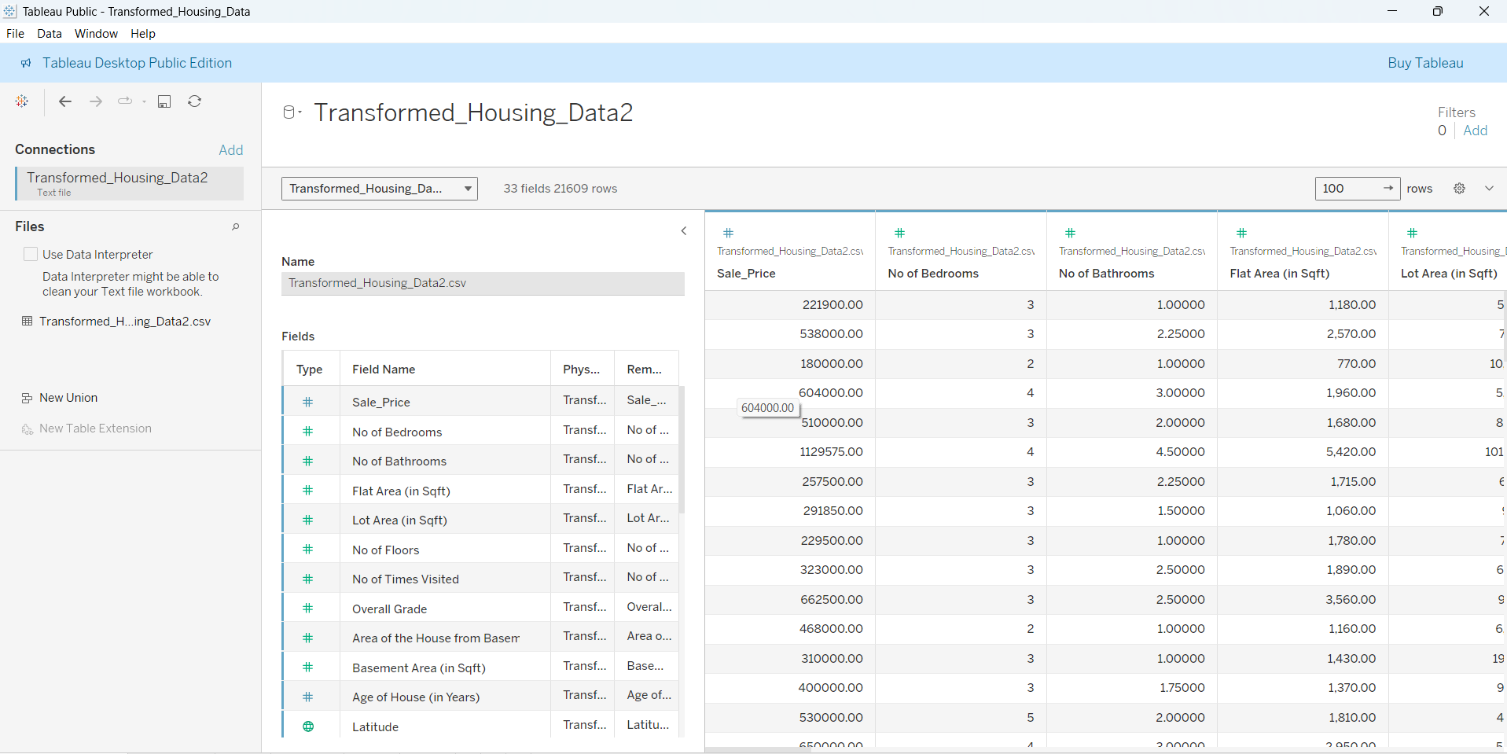
 | Data Preprocessing | Removed 2% null values, encoded categorical variables (Genre, Language), normalized numerical features.  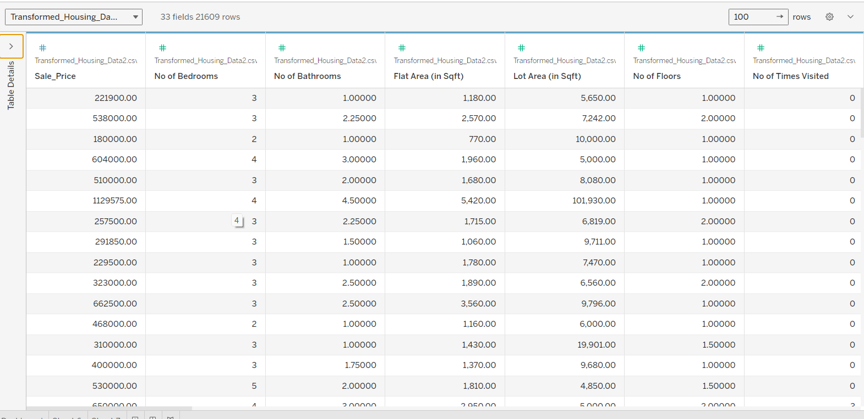
3. | Utilization of Data Filters | For -1  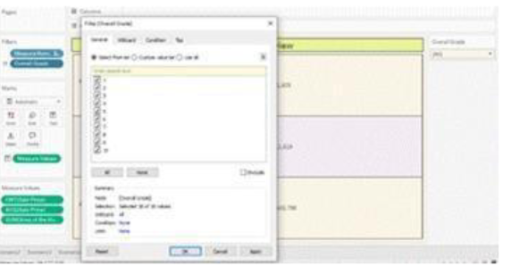  For-2  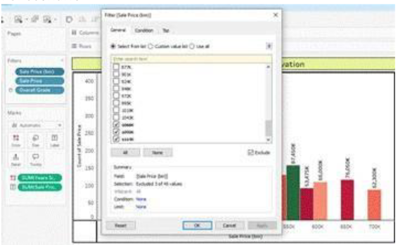  For 3  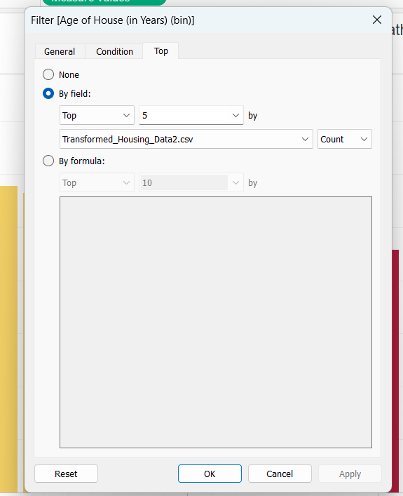
4. | DAX Queries Used | 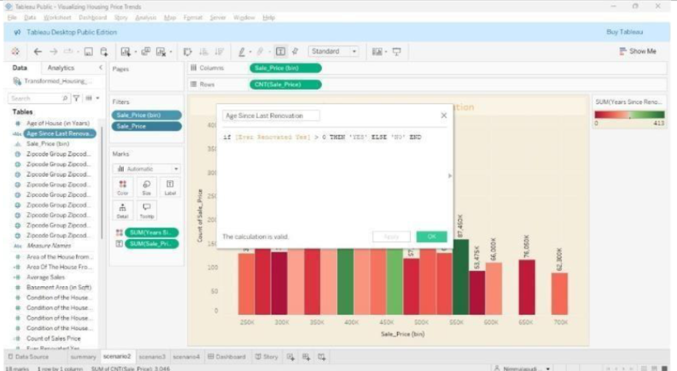
5. | Dashboard design | No of Visualizations / Graphs – 4  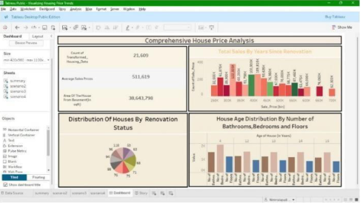
6 | Report Design | No of Visualizations / Graphs -4  